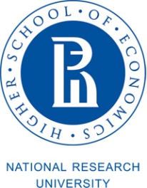 | 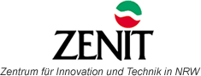 | 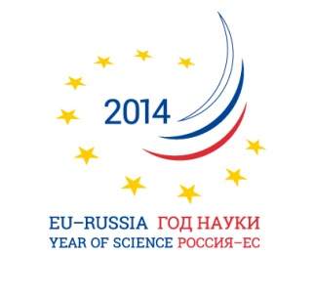 | 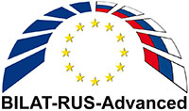 | BILAT-RUS-Advanced project has received funding from the European Union’s Seventh Framework Programme for research, technological development and demonstration under grant agreement no 311836.

BILAT-RUS-Advanced Innovation Policy and Practice Workshop

Integrating Russian Innovation Actors into European Networks: Facilitating Cooperation between Russian and European Technology Platforms

Moscow, May 20 2014

Venue: Higher School of Economics, 20 Myasnitskaya Street, 101000 Moscow, room 311

Agenda
draft
10.00 - 10.45 | Welcome & Introduction to the Workshop  Lyudmila Ogorodova, Deputy Minister of Education and Science of the Russian Federation
S&T and Innovation Policy of Russia and International Cooperation
Artem Shadrin, Director of the Department of Innovative Development, Ministry of Economic Development of the Russian Federation
Sergey Krasilnikov, Deputy Director of the Department of Europe and Americas, Ministry of Economic Development of the Russian Federation
(t.b.c.) Victor Smirnov, Deputy Director of the International Department, Ministry of Education and Science of the Russian Federation

Leonid Gokhberg, First Vice Rector, Higher School of Economics (HSE), Moscow
10.45 – 11:00 | S&T and Innovation Policy of the European Union and International Cooperation  Richard Burger, Head of Science and Technology Session, Delegation of the European Union to the Russian Federation
11.00 – 11.15 | Factors of Cooperation between Russian and European Technology Platforms  Michael Akim, Vice President for Strategic Development, ABB Russia, Head of Committee for Modernistion and Innovation, Association of European Businesses
11.15 - 11.30 | Presentation of BILAT-RUS-Advanced: Cooperation Setting between Russian and European Technology Platforms  Anna Pikalova, Director of Centre for International Projects, HSE Institute for Statistical Studies and Economics of Knowledge
11.30-11:45 | Providing Support to 34 Russian Technology Platforms  Mikhail Rogachev, Director of Russian Foundation for Technological Development
11:45 - 12.00 | Coffee Break
12.00 – 13.00 | Session 2. Exchange of Experience on International Cooperation and Lessons Learnt  Moderated by Michael Guth, ZENIT
Representatives of ETPs and RTPs with interest in international EU-Russia cooperation
ETPs:
- European Technology Platform for Advanced Engineering Materials (EuMaT)
- European Technology Platform for Wind Energy (TPWind)
- European Construction Technology Platform (ECTP)
- NANOfutures Cross-ETP Initiative
13.00-14.00 | Lunch
14.00-15.30 | Session 2. Exchange of Experience on International Cooperation and Lessons Learnt (continued)  Moderated by Anna Pikalova, Director of Centre for International Projects, HSE Institute for Statistical Studies and Economics of Knowledge  RTPs:  - Medicine of the Future  - Bioindustry and Bioresources – BioTech2030  - Light and Reliable Structures  - Technologies for Sustainable Ecological Development  - Bioenergy  - Innovative Laser, Optical and Optoelectronic Technologies – Photonics  - Simulation and Operation Practice of High-Tech Systems (Industry of the Future)
15.30–16.00 | Session 3. International Cooperation: New Opportunities, New Challenges  Interactive session with contributions from all workshop participants  Moderated by Susanne Jakobs-Bohack, ZENIT
16.00-16.15 | Coffee break
16.15-16.45 | Parallel Sessions on possible ETP/RTP cooperation activities  Moderated by Michael Guth, ZENIT; Anna Pikalova, Director of Centre for International Projects, HSE Institute for Statistical Studies and Economics of Knowledge, and Susanne Jakobs-Bohack, ZENIT
16.45 – 17.05 | Presentation of the outcomes of parallel sessions discussions  Michael Guth, ZENIT, and Anna Pikalova, Director of Centre for International Projects, HSE Institute for Statistical Studies and Economics of Knowledge
17.05-17.20 | Closure and next steps Anna Pikalova, Director of Centre for International Projects, HSE Institute for Statistical Studies and Economics of Knowledge

Working languages: Russian & English with simultaneous translation (parallel sessions from16:15-16:45 – English without translation).

